

RapidBuild
How to add new APIs

Prepared by: Rapid Solutions and Consulting LLC
Last Updated: September 25, 2015

Table of Contents
1. Introduction 3
2. INVENTORY creation 4
2. REVERSE sql creation 6
3. LOV definitions 7
4. PL/SQL API code 10
5. INJECTOR API 12
6. BWP GENERATION AND INJECTION 14

1. Introduction

RapidBuild (BUILD) is a tool part of the Rapid client suite used to automate the setup of Oracle Applications configurations using the Oracle Forms playback and HTML technology to inject configurations.

Master data are usually injected using the Oracle public APIs due to volume.

This document describes the process to follow to add a newly developed API code into the Rapid products. At the end of the process, you will be able to use your new API using the datagrid below available in BUILD.

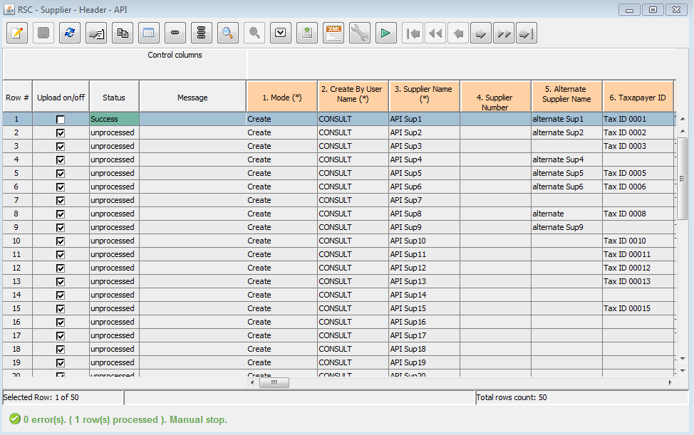

There are 5 files to create in order to fully integrate a new API:
- An inventory file.
- A SQL reverse query.
- A XML file containing the LOV definitions (List Of Values for each field)
- A PL/SQL package to be installed on the EBS server (by BUILD) containing the API code.
- An injector API type (Script)

2. INVENTORY creation

Using the standard RapidConfigurator functionality, you need to create an inventory for all the fields that are supported by the API.

Also, there are 2 special control fields that need to be added first in the inventory: MODE and CREATE BY USER NAME:

- MODE: this is to select the type of injection: either to define a new record or to update an existing record.
- CREATE BY USER NAME: this is a required field for most of the APIs

Once the inventory is created, you will be able to view and prepare data in the table:

2. REVERSE sql creation

This step is optional but very useful if you don't want to key the data manually but to extract it from an existing EBS instance. It needs to contain all the columns that you have added in the inventory.

Please refer to the document “Rapid E-Suite Configurator - How to create Reverse SQL” for more details on how to create a SQL for REVERSE.

Example of SQL query for API data extraction:

Select Distinct CASE WHEN to_date(prl.CREATION_DATE) ##LAST_UPDATE_DATE_OPERATOR## to_date('##SEEDED_DATE##') THEN
##RES_PLSQL_PACKAGE_NAME##.GET_API_CREATE
else
##RES_PLSQL_PACKAGE_NAME##.GET_API_UPDATE
end "Mode"
,##RES_PLSQL_PACKAGE_NAME##.GET_CREATE_BY_USER_NAME "Create By User Name"
, Prl.Name
, Decode(Prl.Mobile_Download, 'Y', 'Yes', 'N', 'No') "Mobile Download"
, Decode(Prl.Active_Flag, 'Y', 'Yes', 'N', 'No') "Active"
, Prl.Description "Description"
, Prl.Currency_Code "Currency"
, Prl.Rounding_Factor
, to_char(prl.START_DATE_ACTIVE, 'DD-MON-YYYY') "Effective Dates - From"
, To_Char(Prl.End_Date_Active, 'DD-MON-YYYY') "Effective Dates - To"
, Freight.Freight_Terms "Freight Terms"
, Rt.Name "Payment Terms"
, Prl.Ship_Method_Code "Freight Carriers"
, Prl.Comments "Comment"
, ##RES_PLSQL_PACKAGE_NAME##.get_organization_name(prl.orig_org_id ) Org_id
, decode(prl.global_flag,'Y','Yes','No') global_flag
, null AS Mapper
From Qp_List_Headers_V Prl
, Ra_Terms Rt
, Oe_Frght_Terms_Active_V Freight
Where Prl.Terms_Id = Rt.Term_Id(+)
And Prl.Freight_Terms_Code = Freight.Freight_Terms_Code(+)
AND (prl.GLOBAL_FLAG = 'Y' or ##RES_PLSQL_PACKAGE_NAME##.validate_ou_name(nvl(prl.ORIG_ORG_ID,-999), '##OPERATING_UNIT_NAME##') = 1)
AND (prl.last_updated_by ##LAST_UPDATED_BY_OPERATOR## (##USER_ID_LIST##) AND prl.last_update_date ##LAST_UPDATE_DATE_OPERATOR## to_date('##SEEDED_DATE##'))
ORDER BY 3

Once created, you can import into your project by the following menu:

3. LOV definitions

The datagrid in BUILD has the capability to show you the data to select in real-time for a specific column as shown below. Basically, it allows to reduce end-user mistakes by selecting valid data or correcting erroneous data.

This is called a LOV (List of Values) popup window.
The definition of those are kept in a XML file with the following format:

<?xml version="1.0"?>
<dataGridLookupColumns xmlns="http://datagrid0000.build.erapidsuite.com">
<dataGrid name="RSC - Price Lists - Price Lists - API" >
<dataGridColumn name="Currency" >
<lookupGrid>
<lookupColumn name="Currency" isVisible="true" isDisplayedValue="true" />
<lookupColumn name="Name" isVisible="true"/>
<query>
select currency_code, name currency_name from fnd_currencies_vl where enabled_flag = 'Y' and currency_flag='Y' and trunc(sysdate) between nvl(start_date_active,trunc(sysdate)) and nvl(end_date_active,trunc(sysdate)) order by currency_code
</query>
</lookupGrid>
</dataGridColumn>
<dataGridColumn name="Payment Terms" >
<lookupGrid>
<lookupColumn name="Payment Terms" isVisible="true" isDisplayedValue="true" />
<lookupColumn name="Description" isVisible="true"/>
<query>
select distinct name , description from ra_terms where trunc(sysdate) &lt;= nvl(end_date_active,trunc(sysdate)) order by name
</query>
</lookupGrid>
</dataGridColumn>
<dataGridColumn name="Freight Terms" >
<lookupGrid>
<lookupColumn name="Freight Terms" isVisible="true" isDisplayedValue="true" />
<query>
select freight_terms from oe_frght_terms_active_v order by freight_terms
</query>
</lookupGrid>
</dataGridColumn>
<dataGridColumn name="Freight Carriers" >
<lookupGrid>
<lookupColumn name="Freight Carriers" isVisible="true" isDisplayedValue="true" />
<lookupColumn name="Description" isVisible="true"/>
<query>
select lookup_code, meaning from oe_ship_methods_v where enabled_flag in ('Y', 'y')
</query>
</lookupGrid>
</dataGridColumn>
</dataGrid>
</dataGridLookupColumns>

Tags explanation:

<dataGrid name="RSC - Price Lists - Price Lists - API" >
The name attribute must be the same name as the inventory.

<dataGridColumn name="Currency" >
<lookupGrid>
<lookupColumn name="Currency" isVisible="true" isDisplayedValue="true" />
<lookupColumn name="Name" isVisible="true"/>
<query>
select currency_code, name currency_name from fnd_currencies_vl where enabled_flag = 'Y' and currency_flag='Y' and trunc(sysdate) between nvl(start_date_active,trunc(sysdate)) and nvl(end_date_active,trunc(sysdate)) order by currency_code
</query>
</lookupGrid>
</dataGridColumn>

You must add one datagridcolumn tag for each field where you need a LOV window.
The name attribute must match the name of the field in the inventory.

The lookupColumn tag corresponds to one column in the LOV window, you can define as many as you need (Example: name | description). The name attribute will be displayed as the column header title.
The IsDisplayedValue attribute must be set to true for the column that you want data to be returned to the main grid, only one column is allowed.
The query tag contains the SQL query to return the list of values to display in the LOV popup window. Note that the select clause must contain the same number of parameters as the number of lookupColumn tags (and in the same order).

Once the LOV XML mapping file is completed, you can import it in your project:

4. PL/SQL API code

The injection of master data is done via your PL/SQL package installed on the EBS.
It should contain at least 1 main function for defining new master data which we call CREATE mode and optionally a UPDATE function for updating existing master data (UPDATE mode).

IMPORTANT:
- The number of parameters for those 2 functions must be the same as the number of fields defined in the inventory.
- Those functions will be called for EVERY record to inject so it needs to return a text for the result of the API processing (Example: success or rejected)
The format of the return result must follow a specific format:

Return Err_Prefix_Lookup||''''||List_Header_Id||''''||' of the column: ''LOOKUP_CODE''' ;

The name of the column must be listed between double quotes so that BUILD can relate the error to the correct field.

See the sample PL/SQL package provided with this document.

Once your PL/SQL package is ready (compiled error free) then you can import it in your project:

5. INJECTOR API

You will need to create a API type script in RapidConfigurator so that it can be included in a scenario and profile in order to generate a BWP. Basically, this file glues all the other files together.

The API injector is a XML file imported via the following menu:

The following format must be used:

<?xml version="1.0"?>
<apiScript xmlns="http://apiscript0000.configurator.erapidsuite.com">
<name>RSC - Price Lists - Price Lists - API</name>
<description>Description of RSC - Price Lists - Price Lists - API</description>
<apiScriptPackage name="XX_RSC_PL_MIGRATION_PKG"
fileName="XX_RSC_PL_MIGRATION_PKG.sql" oracleVersion="12.1.3"
dataType="Price List" inventoryName="RSC - Price Lists - Price Lists - API">
<apiScriptLookup fileName="RSC - Price Lists - Price Lists - API.xml"/>
<apiScriptModes>
<apiScriptMode name="create" procedureName="CREATE_PRICELIST"/>
<apiScriptMode name="update" procedureName="UPDATE_PRICELIST"/>
</apiScriptModes>
</apiScriptPackage>
</apiScript>

<name>RSC - Price Lists - Price Lists - API</name>
This is the name of the script – usually keep it the same as the inventory name.

<apiScriptPackage name="XX_RSC_PL_MIGRATION_PKG"
name: This must be the name of the PL/SQL package created previously
fileName: this must be the name of the PL/SQL file name created previously
oracleVersion: this should be the same version as the EBS targeted.
DataType: just a reference field.
InventoryName: this must be the name of the inventory created in the project.

<apiScriptLookup fileName="RSC - Price Lists - Price Lists – API.xml"/>
fileName: This must be the name of the LOV mapping file.

<apiScriptMode name="create" procedureName="CREATE_PRICELIST"/>
name: you should have a tag for each value of the MODE field (usually CREATE, UPDATE or DELETE)
procedureName: this must be the name of the PL/SQL function to call for this mode (this function must be defined in your PL/SQL package)

6. BWP GENERATION AND INJECTION

Once all the above files are imported into your project, you can then create a scenario containing your API script, prepare the data in the table, create a generation profile with the label containing the data and generate the BWP.

Scenario creation:

Profile creation:

BWP generation:

Finally, download and open the BWP in RapidBuild in order to perform the injection.

You can refer to “Rapid E-Suite Configurator - How to use Datagrid” for more details on the datagrid.

